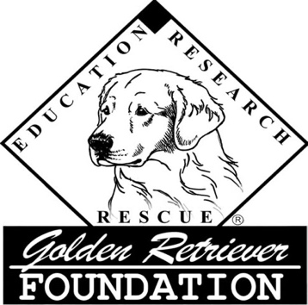

GOLDEN RETRIEVER FOUNDATION®
APRIL FUND GRANT APPLICATION

A tax-exempt organization Revised 04/27/2021
formed by the GRCA

1. Rescue organization

2. Mailing address

Zip

Web site

3. Geographic area served

4. Contact person

Telephone Fax
Please give a phone number that GRF may call to contact a person, NOT an automated voice mail number.
E-Mail

Address
(If check is to be mailed directly to contact person)
5. Amount requested $ Refer to Guidelines for limits and eligibility.

6. Name of Dog (please include a full body photo)

7. Short description of medical procedures

Attach a copy of the veterinary receipt. Receipt must include itemization of services and costs, date that the services were performed, name of the dog and the group or individual that paid for the services. Please indicate which amounts pertain to this application.

8. Is this dog rescued from a puppy mill? Yes No

9. Group’s data on file with: GRF Enclosed
In the form of: Current IRS form 990

10. Signature of Applicant Date

Send completed application to:
Golden Retriever Foundation – 24313 SE 34th Place, Sammamish, Washington 98029

